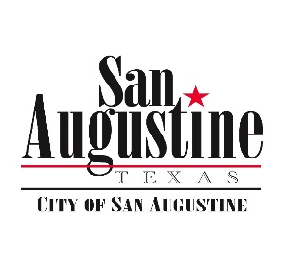**Agenda Item Attachment**

**February 19, 2019 City Council Meeting**

**Agenda Item: 16**

**Submitted by: City Manager**

**Reviewed by:**

**Budgeted Item: N/A**

**For Action:**

**Attachments: None**

**_____**

Park Discussion

**Discussion:**

Since the approval of this year’s budget, Management has been spending the monies from the $50K in the Park Fund working to get our current public areas/parks into better condition. There is vocal interest on Council and in the community for improving our parks and adding to them, but we have been operating under the logic of servicing current parks before taking on new work. To that end we have been actively working on these items as a starting point: (These are in the que, and some not complete)

* Installation of Park Hours Signage per Council to control park use after hours for obvious reasons
* Replacement of the locking gate at the Ball Park following sign installation
* Drying in of the Historic Lewis Hotel
* Grading the grassy areas at the Lewis Hotel and adjoining grounds (County will assist)
* Removal of dead trees in park areas and clearing brush
* Restoration of the boardwalk at the Log Cabin & Replacement of the lights on same
* Clearing the trail on the BNSF from Sante Fe Park to Mission Dolores area
* Working with non-profits, Sheriff’s Office and Shelby Adult Probation where possible

Still to be done/looked at:

* Clean & Paint North Park Playground equipment. We may need to replace some of it or at least consider it.
* Painting on the Caboose at Sante Fe Park
* Address a plan for Ayish Hall on the Bayou
* Updates to various picnic tables, buildings, tennis & basketball facilities at the Ball Park and North Park

All of this is parallel with any effort to Keep San Augustine Beautiful and Main Street

List of Current Park Areas for Discussion:

* North Park – with tables, tennis court and playground equipment on Park Street and Harrison
* Sante Fe Park with Caboose, Ayish Hall and trail head to BNSF Trail (Often overlooked)
* The Log Cabin Lawn with Boardwalk
* The Lewis Hotel and surrounding area across from Santa Fe
* Ball Park on 21 (w/ Little League Partners)
* *Partnerships with the County on Splash Pad Park*

I will try to have some slide by meeting day with photos.

**Recommendation:**

Management continues to recommend we update what we have before spending new money on new parks.

**Recommended Motions:**

Council discretion. We can continue unless you want to redirect our efforts as described.

.