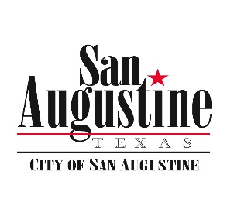**Agenda Item Attachment**

**January 15, 2019 City Council Meeting**

**Item: 15**

**Submitted by: City Manager**

**Reviewed by: Finance**

**Budgeted Item: Yes**

**For Action: Yes**

**Attachments: ACI Agreement & SCADA QUOTE**

**_____**

**Item:**

Discussion and Action If Any to Approve Agreement with ACI Automation, LLC.

**Discussion:**

City Management wants approval to sign an agreement with AIC Automation for providing the technical assistance on Process Controls at the water plant as related to the System itself and the System Control and Data Acquisition (SCADA system). The funding for the base contract is based on the previous budget, and we have negotiated keeping the same rate locked in for the foreseeable future as well as a substantial savings on system upgrades. Hourly costs are inline with or less than comparable rates from competitors, and future system upgrades will be available at a reduced fee. In addition, AIC has a long history of institutional knowledge associated with the peculiarities of the water system we have in San Augustine. Service Level Agreements (SLA’s) are built into the agreement based on our current expectations. Based on contract pricing, we can expect to upgrade the SCADA system for less than $60K as opposed to over $75 with another competitor based on pricing obtained by Management.

Based on pricing, working relationship experience and the recommendation of the City Superintendent the City Manager recommends moving forward with AIC as our partner, and not changing vendors.

Water system upgrades (except for the clear well pumps) will be tabled pending further meetings and

**Recommended Motions:**

I Motion We Approve the City Manager Entering the City into the Agreement with ACI Automation, LLC for Operations at the Water Plant and SCADA System.