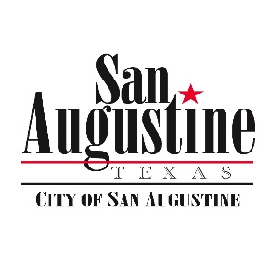**Agenda Item Attachment**

**January 15, 2019 City Council Meeting**

**Item: 14**

**Submitted by: City Manager**

**Reviewed by:**

**Budgeted Item: No / Large Impact**

**For Action: No**

**Attachments: N/A**

**_____**

**Item:**

Discussion of Replacing the Pumps at the Water Plant Clear Well.

**Discussion:**

The City does not have the capacity to pump water into the new ground storage tanks at the required rate. This has been brought up before in the City Manager report. It is an issue which requires addressing more quickly than waiting for the next budget year. While not exactly an emergency, it is a pressing issue for the following reasons: (not an necessarily an exhaustive list)

1. We are unable to pump water from the plant to the storage tanks as fast as we can process it. Therefore, we can never run the plant at maximum output or even find an optimum run rate. This causes treatment issues and added expense in operations for chemicals and overtime on issues.
2. We can not address the plant control system upgrade while this issue remains.
3. Our supply of water to town can not be sustained in times of high usage. This will definitely be a failure point in warm weather or in the event of a major fire or large water main failure.
4. We are not in compliance with TCEQ minimum pump capacity.

The replacement cost for both pumps will fall between $35 & $50K, and we should have precise quotes in time for approval at the February meeting. To meet the cost there are monies available elsewhere in the budget we can repurpose, however those amounts are part of a delayed funding caused by the Federal partial Shutdown.

**Recommended Motions:**

Tabled for subsequent meeting.