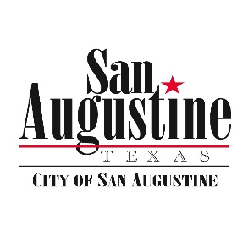**Agenda Item Attachment**

**January 15, 2019 City Council Meeting**

**Item: 13**

**Submitted by: City Manager**

**Reviewed by:**

**Budgeted Item: No / Minimal Impact**

**For Action: Yes**

**Attachments: Site Plan**

**_____**

**Item:**

Discussion and Action If Any To Approve Purchase of an 8x80 strip on Block 13 Immediately south of Lot 84 (on Montgomery Street) for Exchange for $700 and irrevocable access to the Stripling building via the City Alley.

**Discussion:**

The City does not have clear ownership of the referenced strip of land following old transactions. The strip actually is claimed by the Stripling family, and has been discussed in council before today on more than one occasion. It basically corresponds to the “sidewalk” poured north of Imogene’s running from Montgomery to the old Stripling Jail. It bifurcates the City lot immediately adjacent to Montgomery, and City Management wants authority to outright purchase the small piece from the Stripling Family to consolidate the lot for the City while still giving the Striplings an access to the old Jail. The price was arrived at by the square foot with the help of the Appraiser Office. Final transaction will be contingent on proper legal description. The City is currently in a que with the surveyor. The final transaction will be brought before the Council to approve when ready.

**Recommended Motions:**

I make a Motion to Approve Purchase of an 8x80 strip on Block13 immediately south of Lot 84 (on Montgomery Street) in Exchange of $700 and irrevocable access to the Stripling building via the City Alley after proper legal description is made for the transaction, and that the final transaction will be brought before the Council to approve when ready.